**Insights from TechMart Sales Data Analysis**

**1. Product Analysis**

* **Top 5 Most Frequently Purchased Products:**
  + Identified products that are most in-demand using the total quantity purchased.
  + Insights can guide inventory stocking, marketing campaigns, and pricing strategies.
* **Total Sales by Product Category:**
  + Summed up sales grouped by category to identify the most profitable product categories.
  + Results highlight focus areas for marketing and product expansion.

**2. Sales Performance**

* **Monthly Sales Trends for 2024:**
  + Calculated total sales for each month to identify seasonal trends or periods of high/low sales.
  + Helps in demand forecasting and strategic planning.
* **Store with Highest Revenue:**
  + Pinpointed the top-performing store based on total revenue generated.
  + Useful for performance benchmarking across locations.

**3. Customer Loyalty**

* **Customers Purchasing Every Month:**
  + Identified loyal customers who shopped every month in 2024. These customers are prime candidates for rewards programs.
* **Percentage of Repeat Customers:**
  + Determined how many customers made repeat purchases, providing insight into customer retention success.

**4. Debugging Observations**

* Checked data completeness and quality:
  + Confirmed distinct months present in sales data for validation.
  + Analyzed customers' monthly activity to find anomalies.
  + Checked for NULL values in the SaleDate column to address data integrity.
  + Inability to get the SalesDate display with the required date format of YYYY-MM-DD

**5. Regional Trends**

* **Sales by Region:**
  + Highlighted cities generating the highest revenue to identify regions that require more attention or have potential for growth.
* **Region with the Highest Average Sale Value:**
  + Pinpointed cities with the highest average sale value, helping understand regions with premium customers.

**Report Summary**

1. **Product Performance:**
   * Most purchased products and profitable categories revealed demand patterns.
2. **Sales Trends:**
   * Monthly trends and top-performing stores identified opportunities for boosting revenue.
3. **Customer Insights:**
   * Focus on customer retention and loyalty programs is critical.
4. **Regional Analysis:**
   * Highlighted regions for expansion and marketing focus.

**Visual Representations**

To make findings actionable and comprehensible, I used the following visualizations:

1. **Bar Chart:**
   * Top 5 most purchased products by quantity.

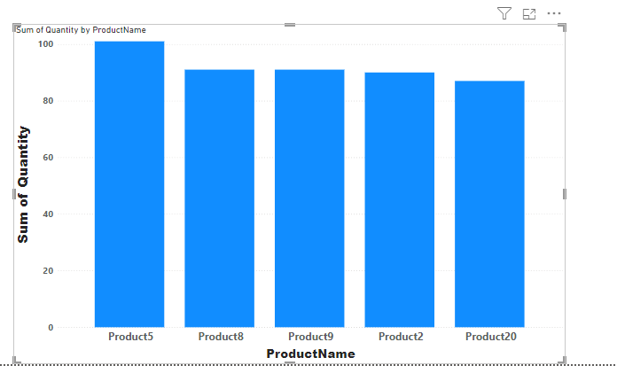

1. **Bar Chart:**
   * Percentage contribution of product categories to total sales.

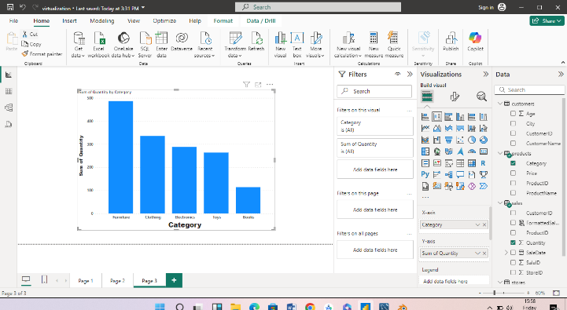

1. **Line Chart:**
   * Monthly sales trends for 2024.

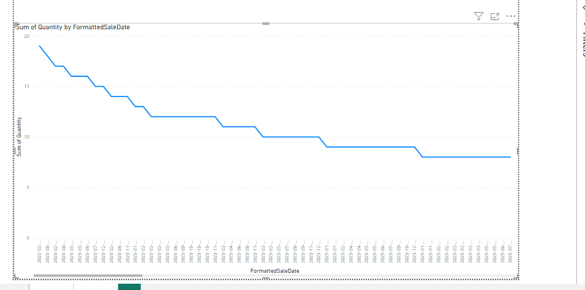

1. **Column Chart:**
   * Total sales by region.

